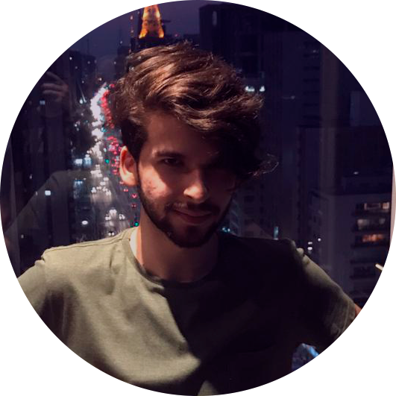

**Gabriel Specie Macedo Marcos**

+55 11 96463-4548 gabriel.specie@gmail.com [www.gabrielspecie.me](http://www.gabrielspecie.me/)

# Qualifications Overview

* 3 years of experience in game development
* Multidisciplinary Game Designer capable of developing prototypes alone
* Professional management experience

# Professional Experience

06/2019 a 01/2020 **Gravlab GameStudio**

Gamestudio focused on outsourcing

## Game Designer / Animator / Game Tester

* Partner
* Game Designer
* Animation direction for games
* Experience with TortoiseSVN version control system
* Experience with Hack N Plan
* Experience with Scrum
* Experience as a playtester porting games for Nintendo Switch
* Customers served: QUbyte Interactive, WePulse

# Academic Degree

**Digital Games Degree** (2017 - 2019)​

Méliès Creative University

# Languages

English - Intermediary/Advanced

Portuguese(Brazil) - Native language

# Skills

Unity

Unreal

Game Design

C#

Rigging(Maya, Blender and Unity)

Animation(Photoshop, Maya e Blender)

Video editing(Adobe Premiere and After Effects)

Modeling Low Poly(Maya and Blender)

UV Opening(Maya and Blender)

Texturing(Substance Painter and Photoshop)

Illustration(Photoshop)

Test(Google Docs and Excel)

# Portfolio

[www.gabrielspecie.me](http://www.gabrielspecie.me/)